Order No: of 2025
Dated: 15-12-2025

In supersession of any previous order(s) on the subject, Mr. Mudasir Rashid, Lecturer-I Automobile Engineering, is hereby assigned the additional charge of Warden, Girls Hostel, in place of Mr. Javeed Ahmad Najar, with immediate effect.
Mr. Javeed Ahmad Najar stands relieved from the additional charge of Warden, Girls Hostel.

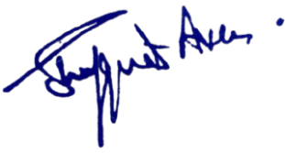

Dr. Shafquat Ara
No: KGP/Estt/2025/
Dated: 15-12-2025

Principal
Kashmir Govt.Polytechnic College
Srinagar

Copy to the:
- Mr. Mudasir Rashid, Lecturer-I, Automobile Engineering – for compliance.
- Mr. Javeed Ahmad Najar,Lecturer-I Leather Technology– for information.
- Hostel File / Personal Files.
- Office Notice Board.
- Concerned for information.

